  - PROJECT PLANNING PHASE

Project Planning: Product Backlog, Sprint Planning & Story Points
Project Name | Auto Ticket Classification Using Flow Designer
Team ID | 6ab1d50c92b876d9664094bc
Prepared Date | 29 September 2026
Planning Basis | Illustrative plan; enter actual team members, dates and completed work before submission.

1. Product Backlog, Sprint Schedule and Estimation
Story points use the supplied planning scale: 1 = very easy, 2 = normal, 3 = moderate, 5 = difficult. The following backlog adapts the template to a rule-based ServiceNow Flow Designer solution; AI/ML is not assumed.
Sprint | Epic | Story ID | User Story / Task | Points | Priority | Team Member
Sprint 1 | Ticket Intake | USN-1 | As an employee, I can submit an incident with a short description and description. | 2 | High | TBD
Sprint 1 | Ticket Intake | USN-2 | As an admin, I can define required ticket fields and validate test records. | 1 | High | TBD
Sprint 1 | Classification Rules | USN-3 | As an admin, I can map keywords or conditions to incident categories. | 3 | High | TBD
Sprint 1 | Classification Rules | USN-4 | As an admin, I can configure a Flow Designer trigger when an incident is created. | 3 | High | TBD
Sprint 1 | Classification Rules | USN-5 | As an admin, I can set a default category for unmatched tickets. | 3 | High | TBD
Sprint 2 | Assignment Automation | USN-6 | As a support manager, I can route categorized tickets to the correct assignment group. | 3 | High | TBD
Sprint 2 | Assignment Automation | USN-7 | As an agent, I can see the assigned category and group on the incident. | 2 | High | TBD
Sprint 2 | Notifications | USN-8 | As an assigned agent, I can receive a notification when a ticket is routed. | 2 | Medium | TBD
Sprint 2 | Testing & Release | USN-9 | As a tester, I can test matched, unmatched and conflicting classification rules. | 3 | High | TBD
Sprint 2 | Testing & Release | USN-10 | As an admin, I can document, activate and verify the flow in a test instance. | 3 | High | TBD
Sprint 1: 12 story points. Sprint 2: 13 story points. Total planned backlog: 25 story points.

2. Project Tracker
Sprint | Planned Points | Duration | Start Date | Planned End | Completed Points | Actual Release
Sprint 1 | 12 | 6 working days | TBD | TBD | Not yet recorded | TBD
Sprint 2 | 13 | 6 working days | TBD | TBD | Not yet recorded | TBD
Suggested sequence: Sprint 1 builds incident intake, rule mapping and the Flow Designer trigger; Sprint 2 adds group assignment, notifications, testing and release. Dates and team ownership must be agreed by the project team.

3. Velocity
Velocity = total story points actually completed ÷ number of completed sprints. Planned average capacity = (12 + 13) ÷ 2 = 12.5 points per sprint. Actual velocity cannot be reported until the team records completed stories.

4. Burndown Chart (Planned Illustration)
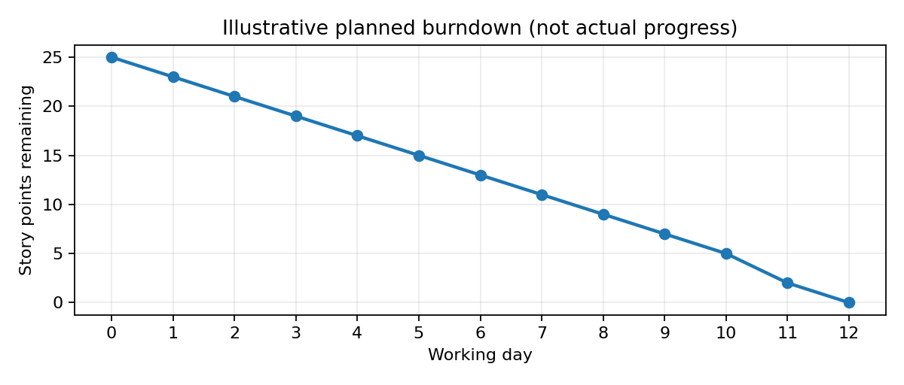
Replace the illustrative line with daily remaining points after work begins. Sprint 1 targets 12 points; Sprint 2 targets 13 points.

5. Delivery and Acceptance
Deliverables: configured incident classification rules, active Flow Designer flow, assignment-group mapping, notification action, test cases and handover notes. Acceptance: sample incidents are classified and routed as configured; unmatched incidents follow the documented fallback path; test results are recorded.

